Graph Theory

A graph is a pictorial representation of a set of objects where some pairs of objects are connected by links. The interconnected objects are represented by points termed as **vertices,** and the links that connect the vertices are called **edges**.

Formally, a graph is a pair of sets (V, E), where V is the set of vertices and E is the set of edges, connecting the pairs of vertices. Take a look at the following graph −

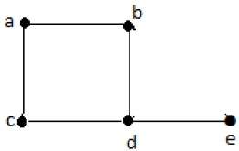

In the above graph,

V = {a, b, c, d, e}

E = {ab, ac, bd, cd, de}

Applications of Graph Theory

Graph theory has its applications in diverse fields of engineering −

* **Electrical Engineering** − The concepts of graph theory is used extensively in designing circuit connections. The types or organization of connections are named as topologies. Some examples for topologies are star, bridge, series, and parallel topologies.
* **Computer Science** − Graph theory is used for the study of algorithms. For example,
  + Kruskal's Algorithm
  + Prim's Algorithm
  + Dijkstra's Algorithm
* **Computer Network** − The relationships among interconnected computers in the network follows the principles of graph theory.
* **Science** − The molecular structure and chemical structure of a substance, the DNA structure of an organism, etc., are represented by graphs.
* **Linguistics** − The parsing tree of a language and grammar of a language uses graphs.
* **General** − Routes between the cities can be represented using graphs. Depicting hierarchical ordered information such as family tree can be used as a special type of graph called tree.

# Basic Properties

## Point

A point is a particular position in a one-dimensional, two-dimensional, or three-dimensional space. For better understanding, a point can be denoted by an alphabet. It can be represented with a dot.

### Example

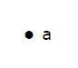

Here, the dot is a point named ‘a’.

## Line

A Line is a connection between two points. It can be represented with a solid line.

### Example

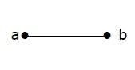

Here, ‘a’ and ‘b’ are the points. The link between these two points is called a line.

## Vertex

A vertex is a point where multiple lines meet. It is also called a node. Similar to points, a vertex is also denoted by an alphabet.

### Example

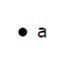

Here, the vertex is named with an alphabet ‘a’.

## Edge

An edge is the mathematical term for a line that connects two vertices. Many edges can be formed from a single vertex. Without a vertex, an edge cannot be formed. There must be a starting vertex and an ending vertex for an edge.

### Example

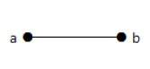

Here, ‘a’ and ‘b’ are the two vertices and the link between them is called an edge.

## Graph

A graph ‘G’ is defined as G = (V, E) Where V is a set of all vertices and E is a set of all edges in the graph.

### Example 1

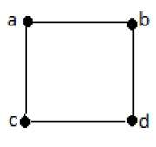

In the above example, ab, ac, cd, and bd are the edges of the graph. Similarly, a, b, c, and d are the vertices of the graph.

### Example 2

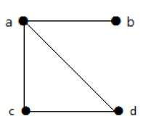

In this graph, there are four vertices a, b, c, and d, and four edges ab, ac, ad, and cd.

## Loop

In a graph, if an edge is drawn from vertex to itself, it is called a loop.

### Example 1



In the above graph, V is a vertex for which it has an edge (V, V) forming a loop.

### Example 2

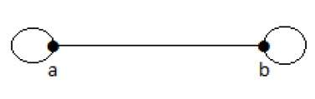

In this graph, there are two loops which are formed at vertex a, and vertex b.

## Degree of Vertex

It is the number of vertices incident with the vertex V.

**Notation** − deg(V).

In a simple graph with n number of vertices, the degree of any vertices is –

**deg(v) ≤ n – 1 ∀ v ∈ G**

A vertex can form an edge with all other vertices except by itself. So the degree of a vertex will be up to the **number of vertices in the graph minus 1**. This 1 is for the self-vertex as it cannot form a loop by itself. If there is a loop at any of the vertices, then it is not a Simple Graph.

Degree of vertex can be considered under two cases of graphs −

* Undirected Graph
* Directed Graph

## Degree of Vertex in an Undirected Graph

An undirected graph has no directed edges. Consider the following examples.

### Example 1

Take a look at the following graph −

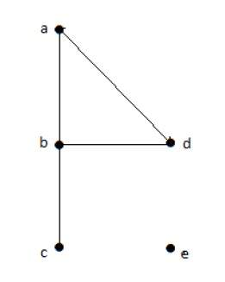

In the above Undirected Graph,

* deg(a) = 2, as there are 2 edges meeting at vertex ‘a’.
* deg(b) = 3, as there are 3 edges meeting at vertex ‘b’.
* deg(c) = 1, as there is 1 edge formed at vertex ‘c’

So ‘c’ is a **pendent vertex**.

* deg(d) = 2, as there are 2 edges meeting at vertex ‘d’.
* deg(e) = 0, as there are 0 edges formed at vertex ‘e’.

So ‘e’ is an **isolated vertex**.

### Example 2

Take a look at the following graph −

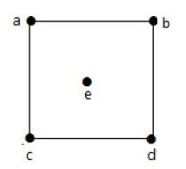

In the above graph,

deg(a) = 2, deg(b) = 2, deg(c) = 2, deg(d) = 2, and deg(e) = 0.

The vertex ‘e’ is an isolated vertex. The graph does not have any pendent vertex.

## Degree of Vertex in a Directed Graph

In a directed graph, each vertex has an **indegree** and an **outdegree**.

### Indegree of a Graph

* Indegree of vertex V is the number of edges which are coming into the vertex V.
* **Notation** − deg+(V).

### Outdegree of a Graph

* Outdegree of vertex V is the number of edges which are going out from the vertex V.
* **Notation** − deg-(V).

Consider the following examples.

### Example 1

Take a look at the following directed graph. Vertex ‘a’ has two edges, ‘ad’ and ‘ab’, which are going outwards. Hence its outdegree is 2. Similarly, there is an edge ‘ga’, coming towards vertex ‘a’. Hence the indegree of ‘a’ is 1.

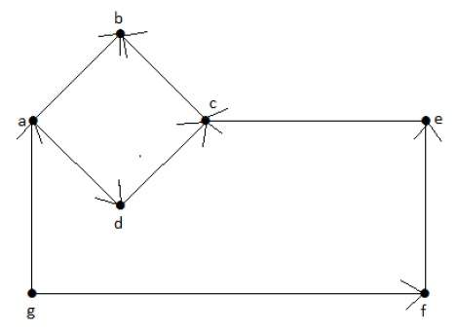

The indegree and outdegree of other vertices are shown in the following table −

|  |  |  |
| --- | --- | --- |
| **Vertex** | **Indegree** | **Outdegree** |
| a | 1 | 2 |
| b | 2 | 0 |
| c | 2 | 1 |
| d | 1 | 1 |
| e | 1 | 1 |
| f | 1 | 1 |
| g | 0 | 2 |

### Example 2

Take a look at the following directed graph. Vertex ‘a’ has an edge ‘ae’ going outwards from vertex ‘a’. Hence its outdegree is 1. Similarly, the graph has an edge ‘ba’ coming towards vertex ‘a’. Hence the indegree of ‘a’ is 1.

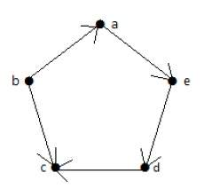

The indegree and outdegree of other vertices are shown in the following table –

|  |  |  |
| --- | --- | --- |
| **Vertex** | **Indegree** | **Outdegree** |
| a | 1 | 1 |
| b | 0 | 2 |
| c | 2 | 0 |
| d | 1 | 1 |
| e | 1 | 1 |

## Pendent Vertex

By using degree of a vertex, we have a two special types of vertices. A vertex with degree one is called a pendent vertex.

### Example

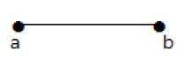

Here, in this example, vertex ‘a’ and vertex ‘b’ have a connected edge ‘ab’. So with respect to the vertex ‘a’, there is only one edge towards vertex ‘b’ and similarly with respect to the vertex ‘b’, there is only one edge towards vertex ‘a’. Finally, vertex ‘a’ and vertex ‘b’ has degree as one which are also called as the pendent vertex.

## Isolated Vertex

A vertex with degree zero is called an isolated vertex.

### Example

Isolated Vertex

Here, the vertex ‘a’ and vertex ‘b’ has a no connectivity between each other and also to any other vertices. So the degree of both the vertices ‘a’ and ‘b’ are zero. These are also called as isolated vertices.

## Adjacency

Here are the norms of adjacency −

* In a graph, two vertices are said to be **adjacent,** if there is an edge between the two vertices. Here, the adjacency of vertices is maintained by the single edge that is connecting those two vertices.
* In a graph, two edges are said to be adjacent, if there is a common vertex between the two edges. Here, the adjacency of edges is maintained by the single vertex that is connecting two edges.

### Example 1

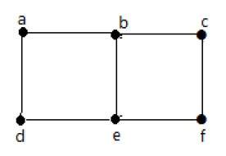

In the above graph −

* ‘a’ and ‘b’ are the adjacent vertices, as there is a common edge ‘ab’ between them.
* ‘a’ and ‘d’ are the adjacent vertices, as there is a common edge ‘ad’ between them.
* ab’ and ‘be’ are the adjacent edges, as there is a common vertex ‘b’ between them.
* be’ and ‘de’ are the adjacent edges, as there is a common vertex ‘e’ between them.

### Example 2

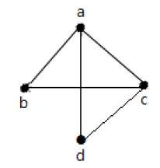

In the above graph −

* a’ and ‘d’ are the adjacent vertices, as there is a common edge ‘ad’ between them.
* ‘c’ and ‘b’ are the adjacent vertices, as there is a common edge ‘cb’ between them.
* ‘ad’ and ‘cd’ are the adjacent edges, as there is a common vertex ‘d’ between them.
* ac’ and ‘cd’ are the adjacent edges, as there is a common vertex ‘c’ between them.

## Parallel Edges

In a graph, if a pair of vertices is connected by more than one edge, then those edges are called parallel edges.

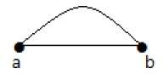

In the above graph, ‘a’ and ‘b’ are the two vertices which are connected by two edges ‘ab’ and ‘ab’ between them. So it is called as a parallel edge.

## Multi Graph

A graph having parallel edges is known as a Multigraph.

### Example 1

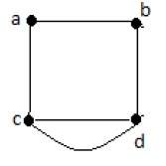

In the above graph, there are five edges ‘ab’, ‘ac’, ‘cd’, ‘cd’, and ‘bd’. Since ‘c’ and ‘d’ have two parallel edges between them, it a Multigraph.

### Example 2

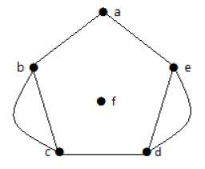

In the above graph, the vertices ‘b’ and ‘c’ have two edges. The vertices ‘e’ and ‘d’ also have two edges between them. Hence it is a Multigraph.

## Degree Sequence of a Graph

If the degrees of all vertices in a graph are arranged in descending or ascending order, then the sequence obtained is known as the degree sequence of the graph.

### Example 1

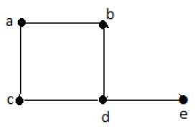

|  |  |  |  |  |  |
| --- | --- | --- | --- | --- | --- |
| **Vertex** | a | b | c | d | e |
| **Connecting to** | b,c | a,d | a,d | c,b,e | d |
| **Degree** | 2 | 2 | 2 | 3 | 1 |

In the above graph, for the vertices {d, a, b, c, e}, the degree sequence is {3, 2, 2, 2, 1}.

### Example 2

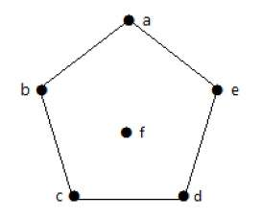

|  |  |  |  |  |  |  |
| --- | --- | --- | --- | --- | --- | --- |
| **Vertex** | A | b | c | d | e | f |
| **Connecting to** | b, e | a, c | B, d | c, e | a, d | - |
| **Degree** | 2 | 2 | 2 | 2 | 2 | 0 |

In the above graph, for the vertices {a, b, c, d, e, f}, the degree sequence is {2, 2, 2, 2, 2, 0}.

## Distance between Two Vertices

It is number of edges in a shortest path between Vertex U and Vertex V. If there are multiple paths connecting two vertices, then the shortest path is considered as the distance between the two vertices.

**Notation** − d(U,V)

There can be any number of paths present from one vertex to other. Among those, you need to choose only the shortest one.

### Example

Take a look at the following graph −

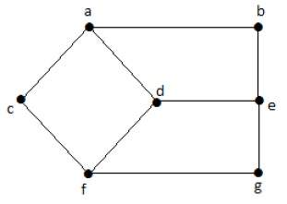

Here, the distance from vertex ‘d’ to vertex ‘e’ or simply ‘de’ is 1 as there is one edge between them. There are many paths from vertex ‘d’ to vertex ‘e’ −

* da, ab, be
* df, fg, ge
* de (It is considered for distance between the vertices)
* df, fc, ca, ab, be
* da, ac, cf, fg, ge

## Eccentricity of a Vertex

The maximum distance between a vertex to all other vertices is considered as the eccentricity of vertex.

**Notation** − e(V)

The distance from a particular vertex to all other vertices in the graph is taken and among those distances, the eccentricity is the highest of distances.

### Example

In the above graph, the eccentricity of ‘a’ is 3.

The distance from ‘a’ to ‘b’ is 1 (‘ab’),

from ‘a’ to ‘c’ is 1 (‘ac’),

from ‘a’ to ‘d’ is 1 (‘ad’),

from ‘a’ to ‘e’ is 2 (‘ab’-‘be’) or (‘ad’-‘de’),

from ‘a’ to ‘f’ is 2 (‘ac’-‘cf’) or (‘ad’-‘df’),

from ‘a’ to ‘g’ is 3 (‘ac’-‘cf’-‘fg’) or (‘ad’-‘df’-‘fg’).

So the eccentricity is 3, which is a maximum from vertex ‘a’ from the distance between ‘ag’ which is maximum.

In other words,

e(b) = 3

e(c) = 3

e(d) = 2

e(e) = 3

e(f) = 3

e(g) = 3

## Radius of a Connected Graph

The minimum eccentricity from all the vertices is considered as the radius of the Graph G. The minimum among all the maximum distances between a vertex to all other vertices is considered as the radius of the Graph G.

**Notation** − r(G)

From all the eccentricities of the vertices in a graph, the radius of the connected graph is the minimum of all those eccentricities.

**Example** − In the above graph r(G) = 2, which is the minimum eccentricity for ‘d’.

## Diameter of a Graph

The maximum eccentricity from all the vertices is considered as the diameter of the Graph G. The maximum among all the distances between a vertex to all other vertices is considered as the diameter of the Graph G.

**Notation** − d(G)

From all the eccentricities of the vertices in a graph, the diameter of the connected graph is the maximum of all those eccentricities.

**Example** − In the above graph, d(G) = 3; which is the maximum eccentricity.

## Central Point

If the eccentricity of a graph is equal to its radius, then it is known as the central point of the graph. If

e(V) = r(V),

then ‘V’ is the central point of the Graph ’G’.

**Example** − In the example graph, ‘d’ is the central point of the graph.

e(d) = r(d) = 2

## Centre

The set of all central points of ‘G’ is called the centre of the Graph.

**Example** − In the example graph, {‘d’} is the centre of the Graph.

## Circumference

The **number of edges in the longest cycle of ‘G’** is called as the circumference of ‘G’.

**Example** − In the example graph, the circumference is 6, which we derived from the longest cycle a-c-f-g-e-b-a or a-c-f-d-e-b-a.

## Girth

The number of edges in the shortest cycle of ‘G’ is called its Girth.

**Notation** − g(G).

**Example** − In the example graph, the Girth of the graph is 4, which we derived from the shortest cycle a-c-f-d-a or d-f-g-e-d or a-b-e-d-a.

## Sum of Degrees of Vertices Theorem

If G = (V, E) be a non-directed graph with vertices V = {V1, V2,…Vn} then

### 

### Corollary 1

If G = (V, E) be a directed graph with vertices V = {V1, V2,…Vn}, then



### Corollary 2

In any non-directed graph, the number of vertices with Odd degree is Even.

### Corollary 3

In a non-directed graph, if the degree of each vertex is k, then

k|V| = 2|E|

### Corollary 4

In a non-directed graph, if the degree of each vertex is at least k, then

k|V| ≤ 2|E|

### Corollary 5

In a non-directed graph, if the degree of each vertex is at most k, then

k|V| ≥ 2|E|